

**Uniform Policy**

September 2024

To be reviewed September 2026

**Executive Head Teacher:** Mrs Roisin Wright

**Chair of Governors:** Canon Mark O’Keeffe

**School Uniform Policy**

It is our school policy that all children wear school uniform when attending school, or when participating in a school-organised event outside normal school hours. We provide a complete list of the items needed for school uniform on our school website.

Our policy on school uniform is based on the notion that school uniform:

* promotes a sense of pride in the school
* engenders a sense of community and belonging towards the school
* is smart
* identifies the children with the school
* makes children feel equal to their peers in terms of appearance
* is regarded as suitable wear for school and good value for money by most parents
* is designed with health and safety in mind

We ask all parents who send their children to our school to support the school uniform policy. All parents sign an agreement on entry to our school stating that they will support all school policies including supporting the uniform policy. We believe that parents have a duty to send their children to school correctly dressed and ready for their day. One of the responsibilities of parents is to ensure that their child has the correct uniform at all times. There may be times throughout the year where children’s shoes are damaged or the child has outgrown their uniform. In this case, we expect a letter from the parent explaining the circumstances and that the parent will replace the uniform within a week. This is to ensure the high expectations for uniform are adhered to.

**Uniform List**

|  |  |
| --- | --- |
| **Boys (winter)** | **Girls (winter)** |
| Dark grey trousers | Navy Blue or Dark Grey skirt, pinafore or trousers |
| White collared shirt | White blouse/collared shirt |
| School tie - elastic tie for EYFS/KS1 neck tie for KS2 | School tie - elastic tie for EYFS/KS1 neck tie for KS2 |
| Royal blue v-neck jumper (preferably with school badge) | Royal blue cardigan or v-neck jumper (preferably with school badge) |
| Plain dark socks | White socks or grey/black/navy/ white tights |
| Sensible black footwear - see appendix | Sensible black footwear - see appendix |

|  |  |
| --- | --- |
| **Boys (summer)** | **Girls (summer)** |
| Dark grey shorts (or trousers) | Royal Blue and white checked dress or Dark Grey shorts |
| White collared shirt/ polo | White blouse/collared/ polo shirt |
| Optional School tie (either neck tie or elastic) | Optional School tie (either neck tie or elastic) |
| Royal blue v-neck jumper (preferably with school badge) | Royal blue cardigan or v-neck jumper (preferably with school badge) |
| Plain socks | White/ grey socks |
| Sensible black shoes | Sensible black shoes |

|  |
| --- |
| **PE for Boys and Girls** |
| School PE T-shirt or plain white/royal blue t-shirt/ polo shirt |
| Plain black/ navy shorts/tracksuit bottoms or leggings and plain black/ navy tracksuit jumper (no logos, patterns or images) |
| Black plimsolls/trainers |

Branded school uniform can be purchased from The Schoolwear Shop, Mayflower Street, Plymouth and The Uniform Shop, George Street, Plymouth.  Please see their websites for opening times.

****Second-hand uniforms****

We have lots of good quality second-hand uniform in school if you wish to look through, or contact Mrs Penelrick, our Schools Parent Support Advisor to arrange a collection.

You can order uniform that has our school logo on for a reduced cost.

**Additional Information**

Trainers are permitted for outdoor PE because they provide more support. They may be either lace-up or velcro fastening although velcro is better for younger children who cannot yet tie laces.

Sensible shoes should be worn. **Boots, sling backs or open toed footwear** is not considered to be sensible. Examples of acceptable footwear can be found in Appendix 1. Whereas we want children to wear shoes as this is the smartest option, we appreciate that some children/parents use ‘pump’ style trainers as shoes so our policy has a compromise as seen in the Appendix.

Tracksuits- children need these for activities taking place outside during cold weather. Tracksuits need to be plain dark blue or black without logos, patterns or images.

Watches may be worn at the discretion of parents, but the school cannot accept responsibility for damage or loss incurred. Alarms or bleepers are not permitted. **NO SMART WATCHES** permitted.

All items of clothing (including shoes, socks, and trainers) must be clearly labelled with your child’s name.

The school is aware of the cost of uniform and acknowledges the guidance from the DFE to ensure uniform is affordable for all. Any parents needing support with sourcing uniform can make an appointment to meet with our PSA who will be able to help.

<https://www.gov.uk/government/publications/cost-of-school-uniforms/cost-of-school-uniforms#the-importance-of-the-cost-of-school-uniform>

***Jewellery, Hair Ornaments, Make-up and Nail Varnish***

For many reasons, including safety, we do not allow children to wear jewellery. The exceptions to this rule are ear-ring studs in pierced ears. Children are required to remove any items during P.E. lessons to prevent them from causing injury.

Please note: School staff are not permitted to remove earrings.

Make up and nail varnish should not be worn to school.

Extreme hairstyles are not appropriate for school. The use of styling products should be kept to a minimum and children should not have decorative patterns cut into their hair or have hair coloured or dyed.

We are passionate in securing the highest standards for our school. By adhering to a clear uniform policy will promote pride and high expectations across the school.

Parents who refuse to follow the uniform/hairstyle policy will be asked to meet and discuss the issue with the Headteacher and representatives from the Governing Body.

**Appendix 1**



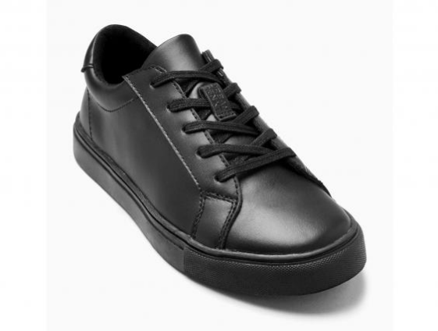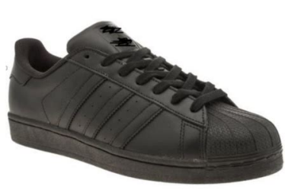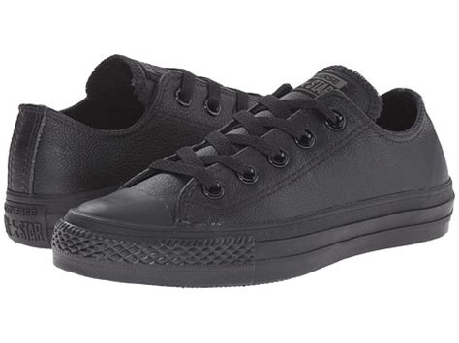

The above footwear are acceptable as they are a close mimic to normal shoes. They are entirely black with no colours.



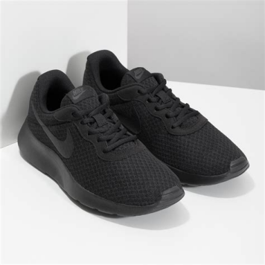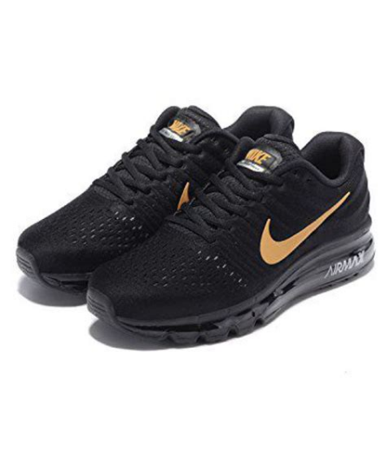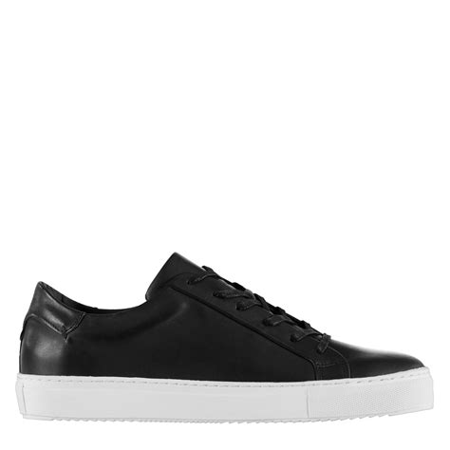

The above footwear **are NOT** acceptable.

The first two trainers are obviously trainers and do not give the smart look that we expect at our school.

The last image, whereas they look similar to those that are acceptable, have a white base and are not ALL black.