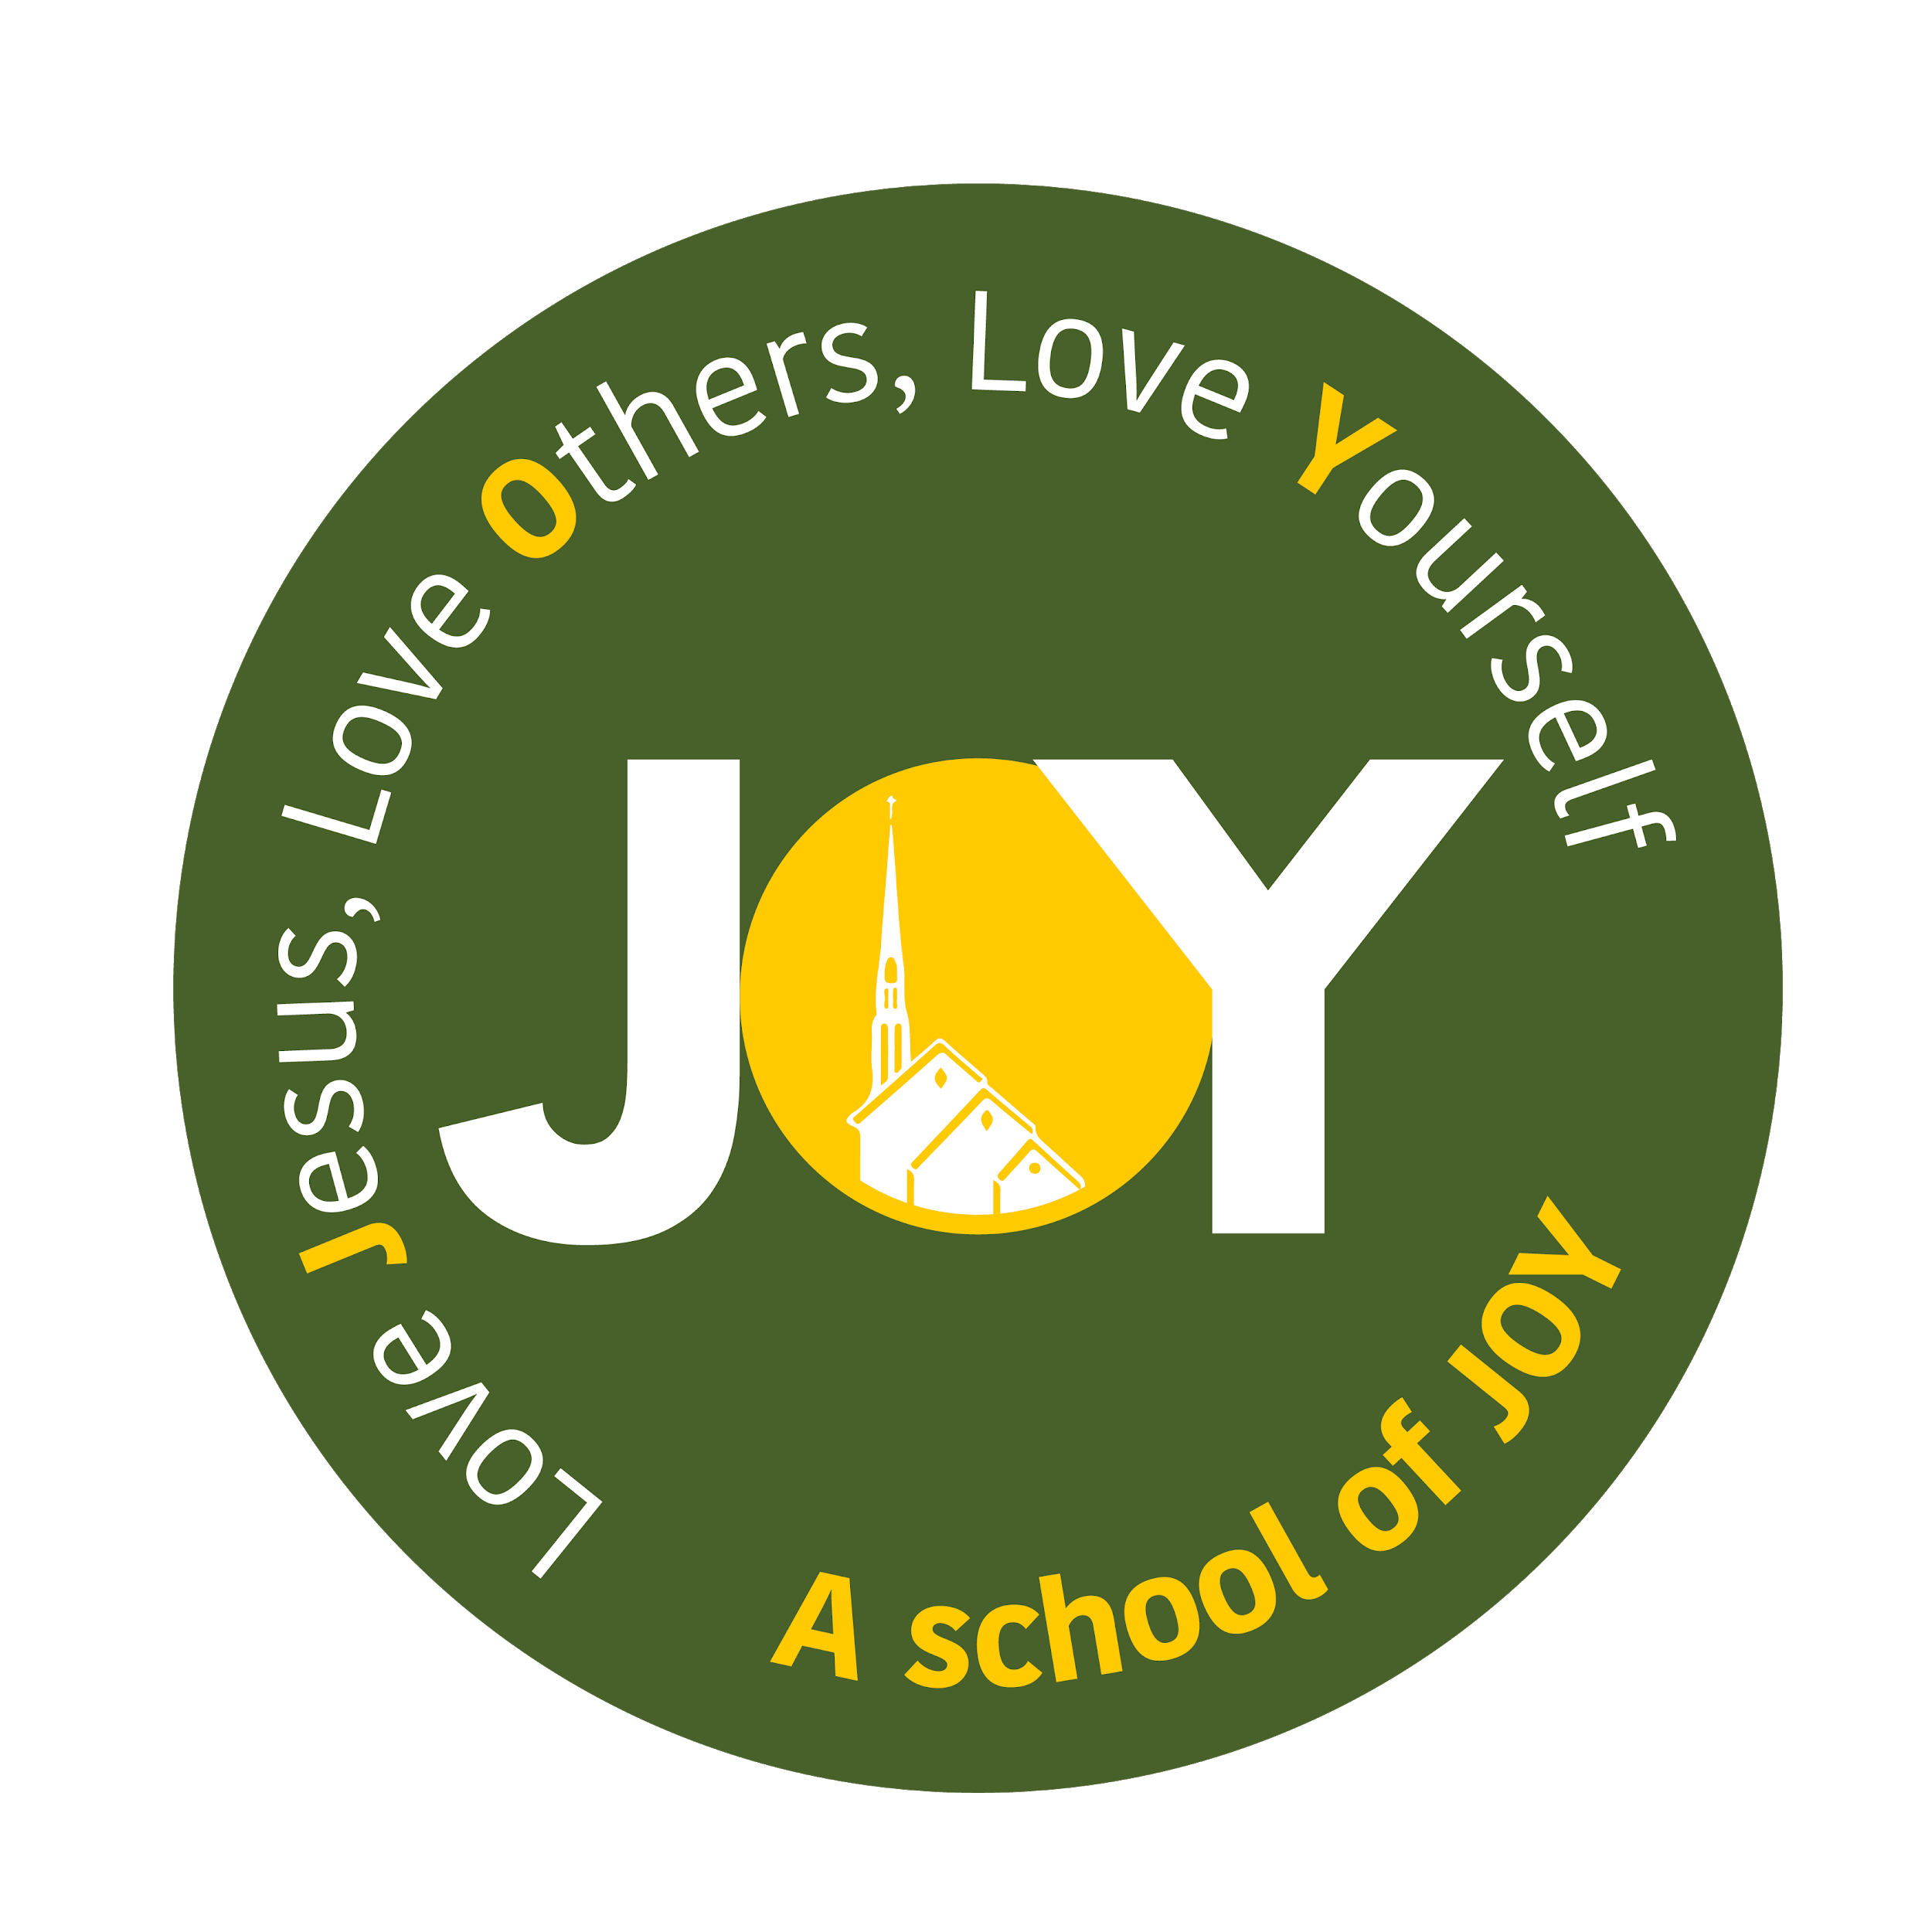

St Joseph's and The Cathedral School of St Mary
Foundation - Autumn Term 1 2024
All About Me!

Foundation | Week 1  WB: 09.09.2023 | Week 2  WB: 16.09.2023 | Week 3  WB: 23.09.2023 | Week 4  WB: 30.09.2023 | Week 5  WB: 07.10.2023 | Week 6  WB: 14.10.2023 | Week 7  WB 21.10.2023  Last week of term
Weekly Theme | Starting school | Who am I? | My body | Who is in my family? | Belonging | Who and what is in my community | People who help us
Vocabulary | School, home, sad, happy, worried, scared, excited, names of children, adults and areas | Self portrait, eyes, nose, mouth, ears, features, hair | Body,height,skeleton, skin, similarities, differences | Family, mum, dad, sister,brother,auntie,uncle,grandma/grandpa ,cousin (also special words the children might use for these people), member | Belong, club, group, teamwork, community | Community, local area, Church, library, shop | Doctor, nurse, firefighter,police officer,ambulance, paramedic, dentist, carers
Key Text | The Colour Monster - Anna Llenas  The Colour Monster Starts School - Anna Llenas  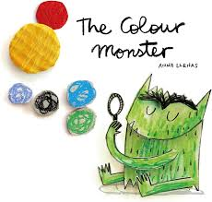 | Super Duper You - Sophie Henn  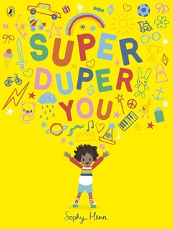 | Happy in our skin - Fran Manushkin  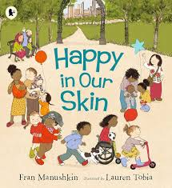 | Families, families, families - Suzanne and Max Lang  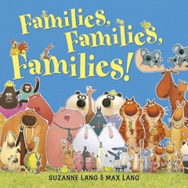 | The Rainbow Fish - Marcus Pfister  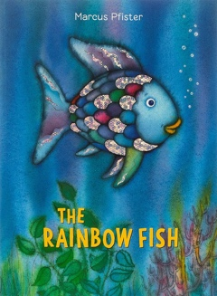 | Last stop on Market Street by Matt De La Pena  The Girl who planted trees by Caryl Hart and Anita Suvorova  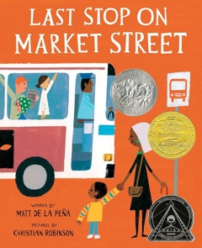  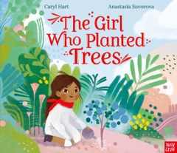 | Real Superheroes - A celebration of key workers by Julia Seal  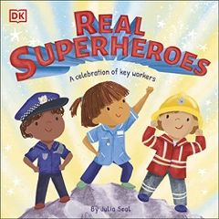
Literacy | Baseline  Understand the key concepts about print  Begin writing and identifying their first name with and then without a reference.  Answer ‘what’ questions related to a story.  Read individual letters by saying the sounds for them. | Baseline  Understand the key concepts about print  Begin writing and identifying their first name with and then without a reference.  Answer ‘what’ questions related to a story.  Read individual letters by saying the sounds for them. | Baseline  Understand the key concepts about print  Continue writing and identifying their first name with and then without a reference.  Answer ‘what’ questions related to a story.  Write some letters.  Read individual letters by saying the sounds for them.  Begin to blend sounds into words so that I can read some short words. | Baseline  Understand the key concepts about print  Continue writing and identifying their first name with and then without a reference.  Answer ‘what’ questions related to a story.  Write some letters.  Read individual letters by saying the sounds for them.  Begin to blend sounds into words so that I can read some short words. | Baseline  Understand the key concepts about print  Continue writing and identifying their first name with and then without a reference.  Answer ‘what’ questions related to a story.  Write some letters.  Read individual letters by saying the sounds for them.  Begin to blend sounds into words so that I can read some short words. | Baseline  Understand the key concepts about print  Continue writing and identifying their first name with and then without a reference.  Answer ‘what’ questions related to a story.  Write some letters.  Read individual letters by saying the sounds for them.  Begin to blend sounds into words so that I can read some short words. | Baseline  Understand the key concepts about print  Continue writing and identifying their first name with and then without a reference.  Answer ‘what’ questions related to a story.  Write some letters.  Read individual letters by saying the sounds for them.  Begin to blend sounds into words so that I can read some short words.
RWI | Initial sound activities in the environment | Begin to introduce RWI | Set 1 | Set 1 | Set 1 | Set 1 | Set 1
Maths | Baseline activities in the environment | Number songs and counting | Numberblocks - numbers 1, 2, 3 | Power Maths:  Unit 1: Numbers to 5 | Power Maths:  Unit 1: Numbers to 5 | Power Maths:  Unit 1: Numbers to 5
RE | Introducing the 3 school prayers  Morning, grace and afternoon | Creation and Covenant:  I know that God made me. | Creation and Covenant:  I know God loves me and I am part of a family. | Creation and Covenant:  I know we should look after ourselves and others | Creation and Covenant:  I know that God made our world. | Creation and Covenant:  I know we should look after God’s world. | Creation and Covenant:  I know that we are all invited to be part of God’s family
PSED/  Gospel Values | Belonging/  Relationships  Tenten - Religious Understanding  ‘Handmade with Love’ | Belonging/  Relationships  Tenten - Religious Understanding  ‘Handmade with Love’ | Belonging/  Relationships  Tenten - Me, my body, my health  ‘I am me’ | Belonging/  Relationships  Tenten - Me, my body, my health  ‘I am me’ | Belonging/  Relationships  Tenten - Me, my body, my health  ‘Heads, shoulders, knees and toes’ | Belonging/  Relationships  Tenten - Me, my body, my health  ‘Heads, shoulders, knees and toes’ | Belonging/  Relationships  Tenten - Me, my body, my health  ‘Ready Teddy’
Communication & Language | Listen and take turns in speaking  Explore feelings using the colour monster book | Children to share something special about them. Is it the same as anyone else? What are the similarities and differences between us as a class. | Head, shoulders, knees and toes  Simon Says..  Naming parts of the body  Explore senses | Choose a member of their family to talk about. Questioning | What does it mean to belong? What groups do we belong to? Children to share groups they belong to eg church, etc. | What makes the communiity. What can you see when you walk around our community. Why should we look after our community and those in it? | Invite a police/firefighter or paramedic in the talk to the children about how they help the community.
Understanding the World | New beginnings  Journey to school What is on their journey to school. How do the children get to school | Discuss what ‘being me’ means.  Complete the ‘I am…’ poster | Look at height, characteristics and features.  Changes in their bodies from when they were a baby  What body parts can they name | Family tree - exploring and then creating their own  Can they create their own family timeline | Discuss what other groups we belong to. Discussion around school of joy badge - belonging to the school family | Look at seasons.  Plant bulbs to bloom within the school community for the change in seasons. | Map the school, and possibly the area around the school.  Look at where the people who help us are.
Expressive Arts and Design | Explore colours using the colour monster - mixing up emotions (colours) and seeing what they get | Painting self-portraits using mirrors to point out key features | Create a funny face using different ears and noses. Decorate the rest of the face. | Recreate a family photo using media of their choice e.g. crayons, pens, paint.  How easy was it to recreate the photo? | Create their own school emblem /family shield / group badge | Listen to a siren sound. Look at the range of instruments that are available to them. Pupils are then to create their own siren sound. | Look at some images of fingerprints. Pupils are to look at their own fingerprints using magnifying glasses.
Computing / Technology |  | Children to use ipad to take pictures of themselves | Recognise and search a range of technology used in the home. | Explore how families communicate with one another and keep in touch, especially with those members they don’t live with eg email, text, etc. | Create a video performance of ‘All join in’ by Quentin Blake. | Talk to the pupils about technology that has been  developed to help people e.g.  dictation programs. | Using pictures on the local area walk and use them to make a map collage.
Physical Development | Fine and Gross motor skills | Fine and Gross motor skills  PE Passport - Fundamental Movement Skills  ‘I can run skillfully and negotiate space’ | Fine and Gross motor skills  PE Passport - Fundamental Movement Skills  ‘I can pick up, carry and put down with care’ | Fine and Gross motor skills  PE Passport - Fundamental Movement Skills  ‘I can show increasing control over an object’ | Fine and Gross motor skills  PE Passport - Fundamental Movement Skills  ‘I can balance and move through an obstacle course’ | Fine and Gross motor skills  PE Passport - Fundamental Movement Skills  ‘I can be excited about and confident in my role in a team’’ | Fine and Gross motor skills  PE Passport - Fundamental Movement Skills  ‘I an thread objects and play games fairly’

